  - Waar
  - Niet waar

_______________________________________________________________________________________________________________________________________________________________________________________
_____________________________________________________________

  - Planten
  - Papier
  - Metalen

  - Kruidenopslag
  - Wapenopslag
  - Slaapplaats voor wachters

- Aan de Rijn
- Aan de IJssel
- Aan de Maas

- Romeinse tijd
- Middeleeuwen
- Napoleontische tijd

  - Vikingen
  - Napoleon
  - Romeinen

  - 48 duizend
  - 110 duizend
  - 23 duizend

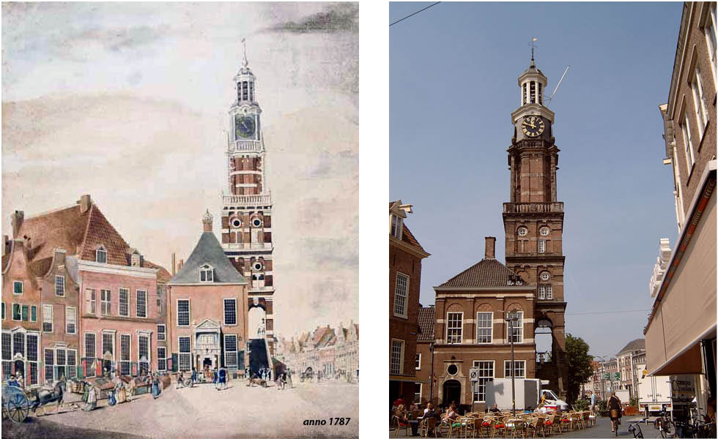

_______________________________________________________________________________________________________________________________________________________________________________________
_____________________________________________________________

  - Rond de tijd 1900
  - Middeleeuwen
  - Romeinse tijd

  - Toegangspoort
  - Vestigingwerken
  - Aardewerken wallen

- Overijssel
- Gelderland
- Utrecht

  - Twee
  - Drie
  - Eén

_______________________________________________________________________________________________________________________________________________________________________________________
_____________________________________________________________

- De Pelikaan
- Sint Janskerk
- Bourgonjetoren

  - Waar
  - Niet waar

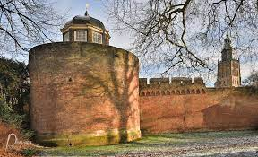
_______________________________________________________________________________________________________________________________________________________________________________________
_____________________________________________________________
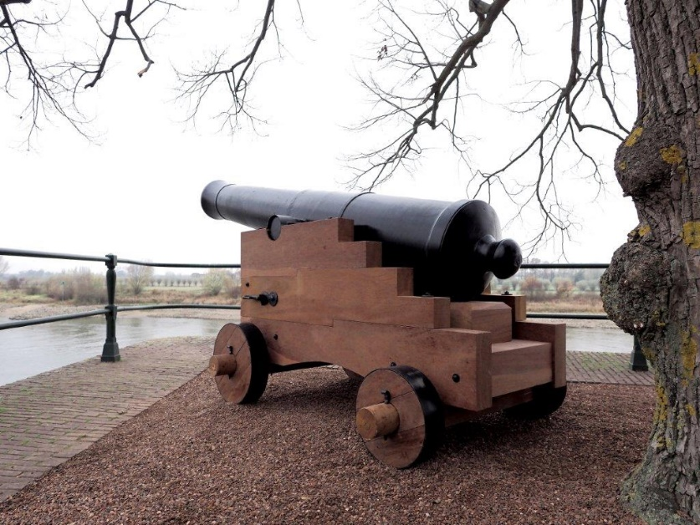

____________________________________________________________________________________________________________________________________________________________________________________________________________________________________________________

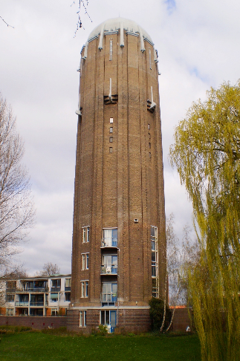
_______________________________________________________________________________________________________________________________________________________________________________________
_____________________________________________________________
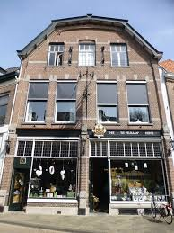
_______________________________________________________________________________________________________________________________________________________________________________________
_____________________________________________________________

  - Albert Heijn
  - Coop
  - Spar

  - Drukke winkelkorting
  - Drukke wegkwartier
  - Deventerweg kwartier

  - Een mengsel van kruiden
  - Een jenevertje
  - Een hoestdrankje

  - Blauw, wit en rood
  - Rood, wit en oranje
  - Geel en blauw

